 | Boost is Lancashire's Business Growth Hub and one of 41 Growth Hubs across the UK. It is led by Lancashire County Council.  www.boostbusinesslancashire.co.uk
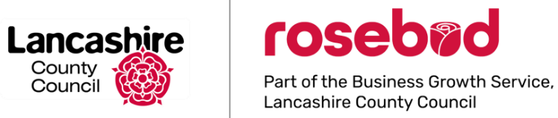 | Rosebud, part of the Business Growth Service in Lancashire County Council, provides business loans to established companies ranging from £25k-£100k.  www.rosebudfinance.co.uk

